**How to use MS-Access for Data Management**

Click on MS-Access and click on open to select the database or click on the database “AAWC” from the folder.

Enter the password to open the database.

**(Note: Remember the database password because in case you forget the password it cannot be retrieved.)**

You can see four options on your left hand side – Tables, Queries, Forms and Reports.

Tables: It stores the values you put in. You can modify records in the tables directly but that is not recommended. To view the records of a table it is recommended to export the tables in an excel sheet and view them.

**(Note: Do not modify the tables)**

**To export a table:**

1. Select a table.
2. Click on “External Data” on the main menu.
3. In the “Export” option select “Excel”
4. On the pop up select the path where you want to store the excel file.
5. Click on “OK”
6. Click on “Close”
7. Open the excel file saved.

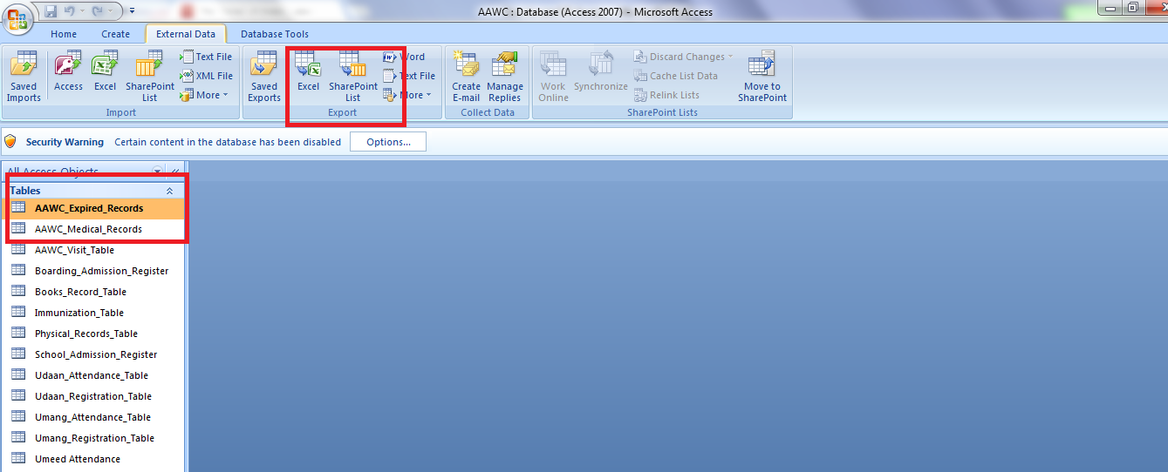

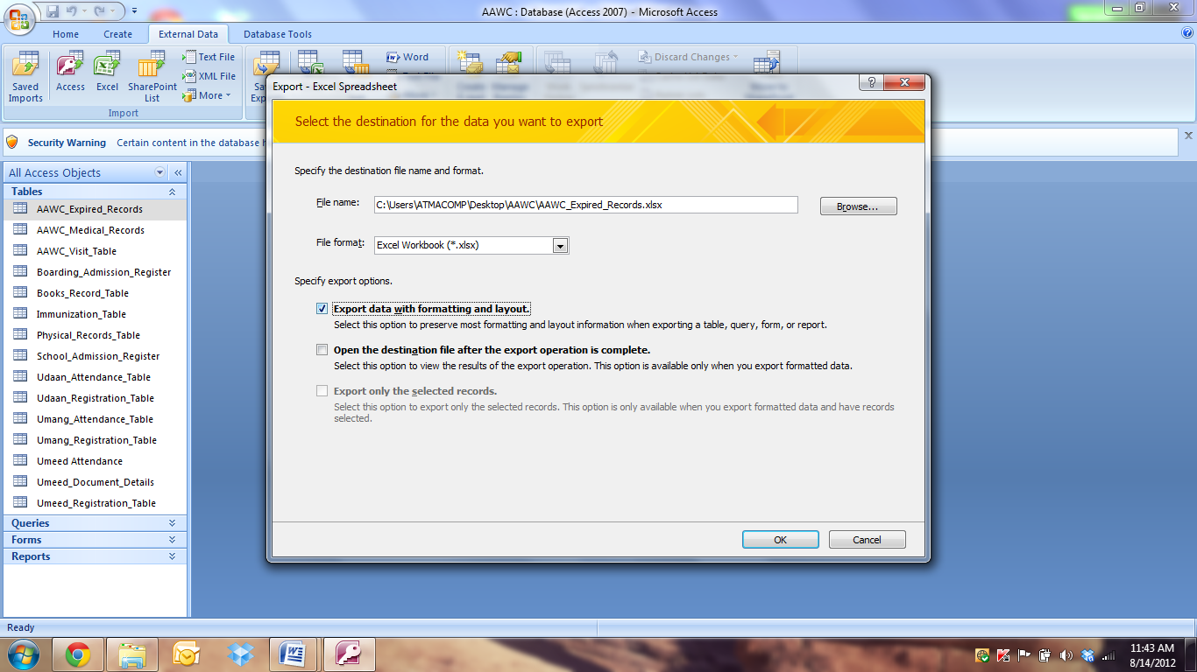

**To import a file into a table:**

1. Click on “External Data” on the main menu.
2. In the “Import” option select “Excel”
3. On the pop up select the path from where to pick the excel file. (under the File name section)
4. Select the second option “Append a copy of the records to the table” and select the table in which you want to store the data. (This option will be used to insert attendance and physical records in the table)
5. Click on “OK”
6. Click on “Close”
7. Check the table if all the records are inserted properly

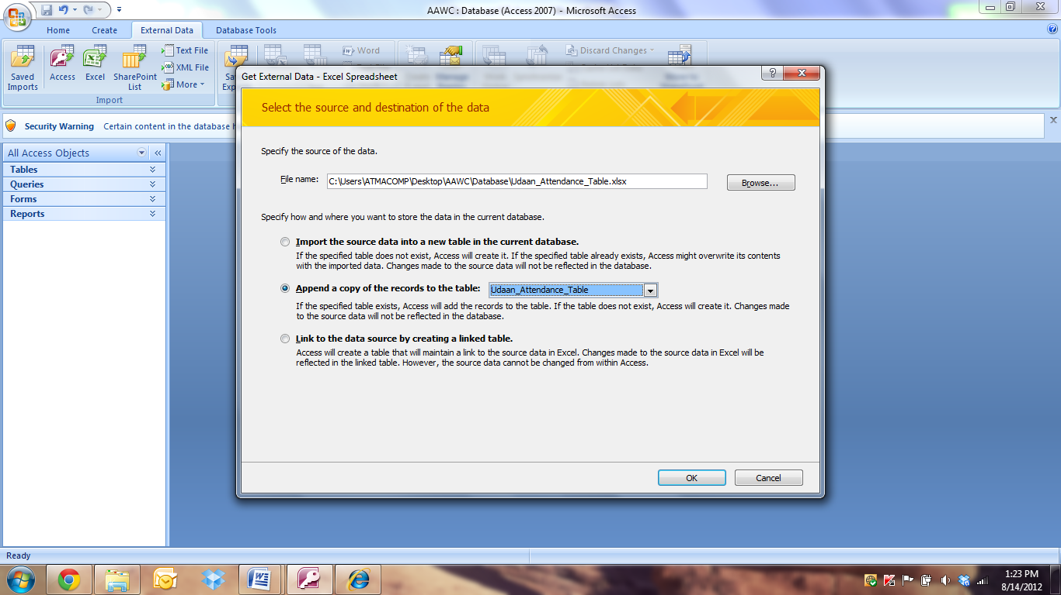

**Queries:**

It stores the queries which are used to generate report.

**(Note: Do not open or modify the queries)**

**Forms:**

You can enter the values on the forms which gets stored in the tables. Details about each form is covered individually.

**Reports:**

You can view the reports on clicking on the reports and entering the parameters. Details about each report is covered individually.

**Database Back Up:**

This is the most crucial step in maintaining an Access database. Database backup should be carried out every week and stored at a different drive than where the database is stored. In case of drive failure you can retrieve the latest copy. Monthly backups should also be saved on an external device (CD, DVD, Pen Drive, laptop, alternate machine). As you create regular backups the oldest backups can be deleted but double check before deleting a database copy.

Steps to take database backup:

1. Click on Manage as shown in the image below.
2. Select “Back Up Database” option
3. Database backup is created and saved at the location mentioned.

